**Number Systems Used In Computers**

Complete the following table:

|  |  |  |  |
| --- | --- | --- | --- |
| **Number System** | **Number Base** | **Digits Used** | **Purpose** |
| Decimal | Base 10 | 0 to 9 | Used for communicating with human users |
| Binary |  |  |  |
| Octal |  |  |  |
| Hexadecimal |  |  |  |

**Decimal vs. Binary System**

Write down the definition of a **Bit** in computer terminology:

Complete the following table:

|  |  |  |
| --- | --- | --- |
|  | **Decimal System** | **Binary System** |
| Uses Digits |  |  |
| Addition Examples |  |  |
| Powers of 10 |  |  |
| Evaluate 111 |  |  |

**Powers of 2**

|  |  |  |  |  |
| --- | --- | --- | --- | --- |
| **Power  of 2** | **Decimal Value** | **Integer Range** | **Number  of Bits** | **Computer Binary** |
| 21 | 2 | 0 - 1 | 1 | 0001 |
| 22 | 4 | 0 - 3 | 2 | 0011 |
| 23 |  |  |  | 0111 |
| 24 |  |  |  | 1111 |
| 25 |  |  |  | 0001 1111 |
| 26 |  |  |  | 0011 1111 |
| 27 |  |  |  | 0111 1111 |
| 28 | 256 | 0 - 255 | 8 | 1111 1111 |
| 29 |  |  |  | 0001 1111 1111 |
| 210 |  |  |  | 0011 1111 1111 |
| 211 |  |  |  | 0111 1111 1111 |
| 212 |  |  |  | 1111 1111 1111 |
| 213 |  |  |  | 0001 1111 1111 1111 |
| 214 |  |  |  | 0011 1111 1111 1111 |
| 215 |  |  |  | 0111 1111 1111 1111 |
| 216 | 65,536 | 0 – 65,535 | 16 | 1111 1111 1111 1111 |

**Conversions**

Convert the following binary numbers to decimal:

11 binary =

101 binary =

1010 binary =

Convert the following decimal numbers to binary:

6 decimal =

13 decimal =

**Binary Addition**

Add the following binary numbers. (verify your answers using decimal)

|  |  |  |  |  |  |  |  |  |  |  |  |  |  |
| --- | --- | --- | --- | --- | --- | --- | --- | --- | --- | --- | --- | --- | --- |
| |  |  | | --- | --- | | **0101** | **(decimal 5)** | | **+ 0010** | **(decimal 2)** | |  |  | | |  |  | | --- | --- | | **0101** | **(decimal 5)** | | **+ 1010** | **(decimal 10)** | |  |  | |
| |  |  | | --- | --- | | **0011** | **(decimal 3)** | | **+ 0010** | **(decimal 2)** | |  |  | | |  |  | | --- | --- | | **0110** | **(decimal 6)** | | **+ 0011** | **(decimal 3)** | |  |  | |

**Prefixes**

* Kilo (K) means __________________ Multiply by x______________
* Mega (M) means _________________ Multiply by x______________

* Giga (G) means __________________ Multiply by x______________
* Tera (T) means __________________ Multiply by x______________

**Examples**

1. 64 Kbps (Kilo-bits per seconds) = ___________________ bps (bits per second)
2. 256 Giga-bytes = _________________________________ bytes
3. 256 Giga-bytes = _________________________________ bits

**Computer Memory Structures**

|  |  |  |  |
| --- | --- | --- | --- |
| **Structure** | **Number of Bits** | **Largest Value** | **Used For...** |
| Bit |  |  |  |
| Byte |  |  |  |
| Word |  |  |  |
| Short Integer |  |  |  |
| Double Word |  |  |  |
| Long Integer |  |  |  |
| Memory Address |  |  |  |

**Memory Organization**

Bit (Binary Digit)

* One bit can have a value of ________ or _________
* Or a Boolean logic value of ________ or _________

|  |  |  |  |  |  |  |  |  |  |  |  |  |  |  |  |  |  |  |  |
| --- | --- | --- | --- | --- | --- | --- | --- | --- | --- | --- | --- | --- | --- | --- | --- | --- | --- | --- | --- |
| |  |  |  |  | | --- | --- | --- | --- | | 0 | 0 | 0 | 0 | | |  |  |  |  | | --- | --- | --- | --- | | 0 | 0 | 0 | 0 | | |  |  |  |  | | --- | --- | --- | --- | | 0 | 0 | 0 | 0 | | |  |  |  |  | | --- | --- | --- | --- | | 0 | 0 | 0 | 0 | |

Byte (8 bits)

* One byte has a size of ________ bits
* A byte has an unsigned integer value range from 0 to _________

|  |  |  |  |  |  |  |  |  |  |  |  |  |  |  |  |  |  |  |  |
| --- | --- | --- | --- | --- | --- | --- | --- | --- | --- | --- | --- | --- | --- | --- | --- | --- | --- | --- | --- |
| |  |  |  |  | | --- | --- | --- | --- | | 0 | 0 | 0 | 0 | | |  |  |  |  | | --- | --- | --- | --- | | 0 | 0 | 0 | 0 | | |  |  |  |  | | --- | --- | --- | --- | | 0 | 0 | 0 | 0 | | |  |  |  |  | | --- | --- | --- | --- | | 0 | 0 | 0 | 0 | |

Word (2 bytes or 16 bits)

* One word has a size of ________ bits
* One word has a size of ________ bytes
* A byte has an unsigned integer value range from 0 to _________

|  |  |  |  |  |  |  |  |  |  |  |  |  |  |  |  |  |  |  |  |
| --- | --- | --- | --- | --- | --- | --- | --- | --- | --- | --- | --- | --- | --- | --- | --- | --- | --- | --- | --- |
| |  |  |  |  | | --- | --- | --- | --- | | 0 | 0 | 0 | 0 | | |  |  |  |  | | --- | --- | --- | --- | | 0 | 0 | 0 | 0 | | |  |  |  |  | | --- | --- | --- | --- | | 0 | 0 | 0 | 0 | | |  |  |  |  | | --- | --- | --- | --- | | 0 | 0 | 0 | 0 | |
|  | |  | |

Long or Double Word (4 bytes or 32 bits)

* One Long word has a size of ________ words
* A Long word has an unsigned integer value range from 0 to _________

|  |  |  |  |  |  |  |  |  |  |  |  |  |  |  |  |  |  |  |  |
| --- | --- | --- | --- | --- | --- | --- | --- | --- | --- | --- | --- | --- | --- | --- | --- | --- | --- | --- | --- |
| |  |  |  |  | | --- | --- | --- | --- | | 0 | 0 | 0 | 0 | | |  |  |  |  | | --- | --- | --- | --- | | 0 | 0 | 0 | 0 | | |  |  |  |  | | --- | --- | --- | --- | | 0 | 0 | 0 | 0 | | |  |  |  |  | | --- | --- | --- | --- | | 0 | 0 | 0 | 0 | |
|  | |  | |
| |  |  |  |  | | --- | --- | --- | --- | | 0 | 0 | 0 | 0 | | |  |  |  |  | | --- | --- | --- | --- | | 0 | 0 | 0 | 0 | | |  |  |  |  | | --- | --- | --- | --- | | 0 | 0 | 0 | 0 | | |  |  |  |  | | --- | --- | --- | --- | | 0 | 0 | 0 | 0 | |
|  | |  | |

**Questions**

1. What is the smallest memory object that can represent a character of information?
   1. Think… How many upper case letters in the alphabet (A to Z)?

There are 26 upper case letters in the alphabet

* 1. Think… How many lower case letters in the alphabet (a to z)?

There are 26 lower case letters in the alphabet

* 1. Think… How many number digits (0 to 9)?

There are 10 digits for 0-10

* 1. Think… How many punctuation marks?

There are 14 punctuation marks

* 1. Add them all up

In total there would be 76 characters

1. Research the ASCII characters set. What is it and how is it related to computer memory?

ASCII is an Amercian Standard Code for Information and Interchange. ASCII and all computers use binary systems. The ASCII characters are set as one byte. The memory is stored in most appropriate hardware.

1. How are strings of characters (Google “String”) represented in computer memory?

 Each character is stored one after another and it stores as the ASCII value of each character.

1. How are negative integers represented in computer memory? (Include a diagram)

A zero is put in front of the number if it is positive and a 1 is put in front of the number if it is negative.

8 bit word

         00110101 = +53

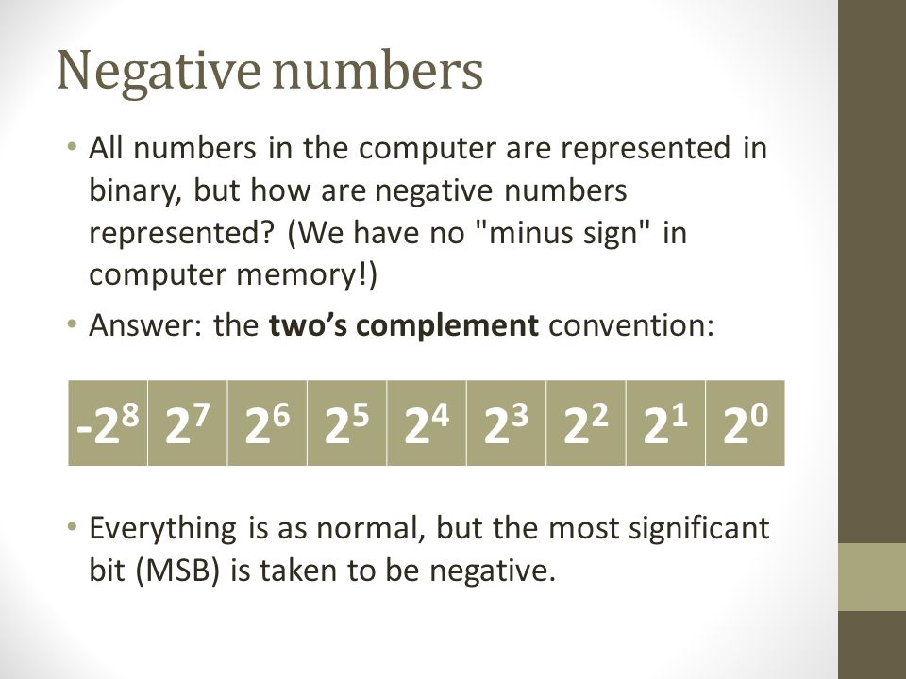

1. How are decimal numbers (Google “Floating Point”) represented in computer memory? (Include a diagram)

Decimals are represented using a standard called the IEEE 754 which has 3 parts the sign of mantissa which is if the number is positive or negative, the biased exponent which adds a bias to the exponent, and the normalized mantissa which consists of significant digits.

32 bit

|  |  |  |
| --- | --- | --- |
| Sign | Exponent | Mantissa |

        1 Bit                                       8 Bits                                   23 bits

1. A Pixel is computer memory structure used to store image information. How is a Pixel represented in memory? (Include a diagram).

A pixel is represented by a fixed number of bits. The typical pixel bit depth is 32, 16, 8, or 1 for binary images.

1 pixel